

# Practices for Secure Software Report

Table of Contents

Document Revision History 3

Client 3

Instructions 3

Developer 4

1. Algorithm Cipher 4

2. Certificate Generation 4

3. Deploy Cipher 5

4. Secure Communications 5

5. Secondary Testing 6

6. Functional Testing 20

7. Summary 21

8. Industry Standard Best Practices 22

## Document Revision History

| **Version** | **Date** | **Author** | **Comments** |
| --- | --- | --- | --- |
| **1.0** | **December 10, 2023** | **David Cruz** |  |

## Client



## Developer

David Cruz

## Algorithm Cipher

Artemis Financial needs to encrypt sensitive information and files used within their business using a strong and reliable cipher algorithm. Using a trustworthy algorithm from Java Security Standard Algorithm Names made by Oracle, the algorithm should comply with security standards established by various governments and be resistant to cyber-attacks. The recommended cipher algorithm is Advanced Encryption Standard (AES) using Secure Hash Algorithm (SHA) 256-bit encryption cipher. This key cipher uses symmetric cryptography and a secret key, where this same key is used for both encrypting and decrypting the data (Manico & Detlefsen, 2014, p.161).

The cipher generates encryption keys and uses random numbers to make the encryption process more complex. These symmetric keys require a secure channel between the two destinations during data transit because the same key is needed for encryption and decryption. Symmetric keys differ from non-symmetric keys, as non-symmetric keys do not require the keys to be the same for encryption and decryption and are more secure and complex but are slower and take longer to compute. The sharing of symmetric keys is safe, speedy, and reliable, and there are various best practices that Artemis Financial can follow to ensure the secure transfer of the keys.

In particular, to ensure that the keys stay secure, it is recommended that best practices given by the Cybersecurity & Infrastructure Security Agency are followed, such as: Identifying key management authorities, roles, and responsibilities, Develop an encryption key management plan to protect against compromise and reduce operational uncertainty, coordinate key management plan with partner agencies, and limit key distribution only to authorized entities among other best practices (CISA, p.3). AES is one of the most popular and widely used algorithms today, unlike classical algorithms like Caesar Cipher that are easy to crack. With AES, Artemis Financial can be confident in the encryption of their archive files.

## Certificate Generation

The certificate was generated using the Keytool extension in Eclipse IDE.

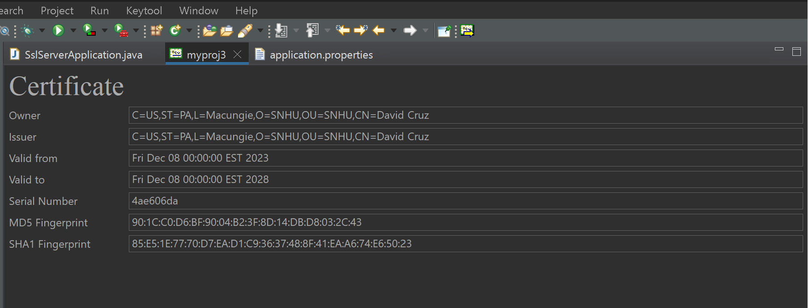

## Deploy Cipher

Checksum verification using port 8080 and HTTP.

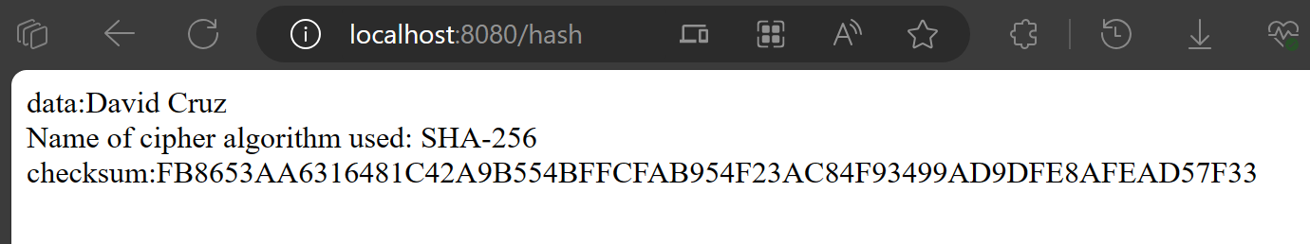

## Secure Communications

Application.properties

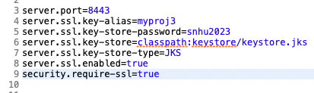

Using port 8442 and using HTTP

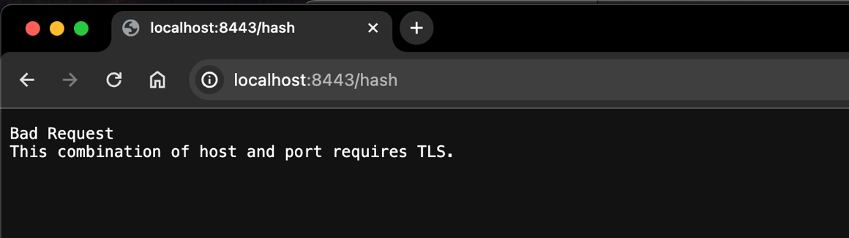

Changed port to 8442 and using HTTPS

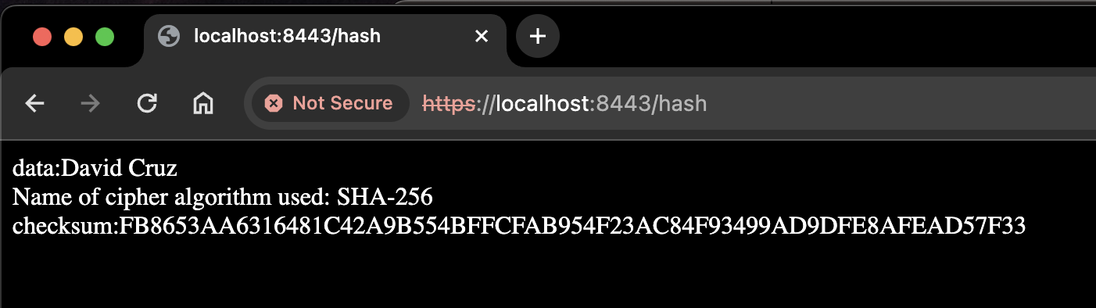

The screenshot above demonstrating HTTPS is showing that the connection is not secure. This is due to the selfsigned certificate not verified by a third party. When we are using an external Certificate Authority (CA), this will not be the case.

## Secondary Testing

A Maven Dependency Check was run before refactoring code. This was done to check if any new vulnerabilities were introduced after refactoring the code.

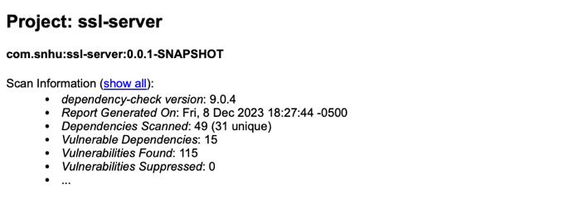

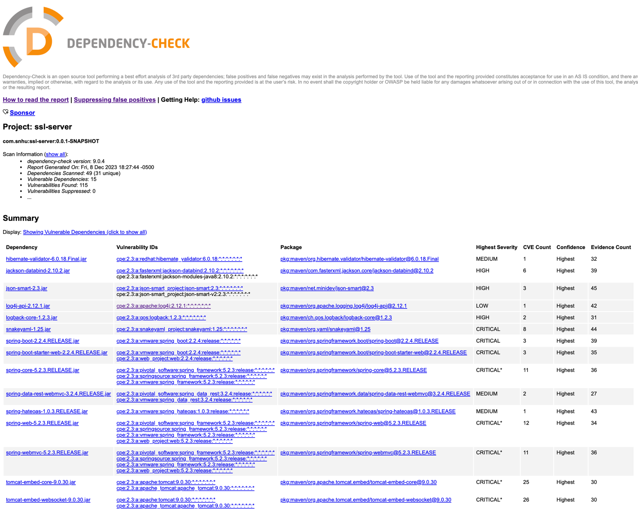

SslServerApplication.java (Before refactoring)

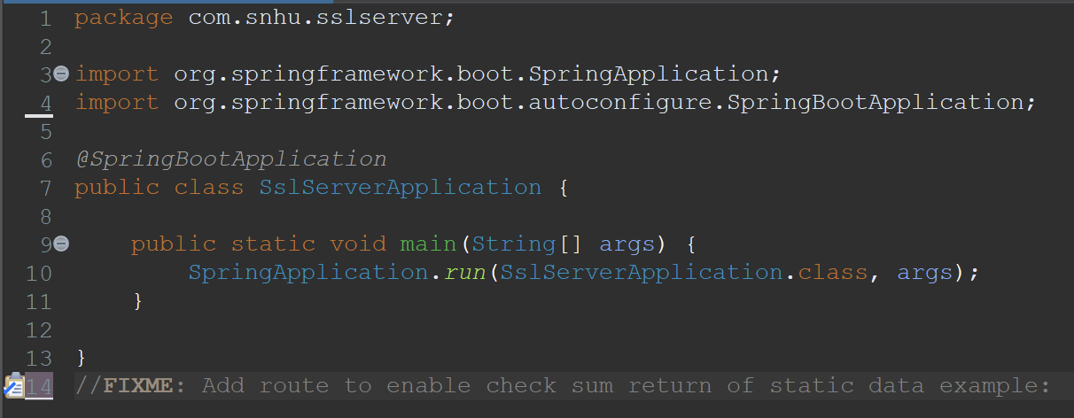

Almost all vulnerabilities were removed to see if any new vulnerabilities arose after refactoring the code. Some vulnerabilities continued to show on the report regardless of being included in the suppression.xml file. Here were the results of the dependency check after suppressing vulnerabilities.

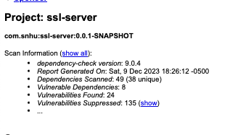

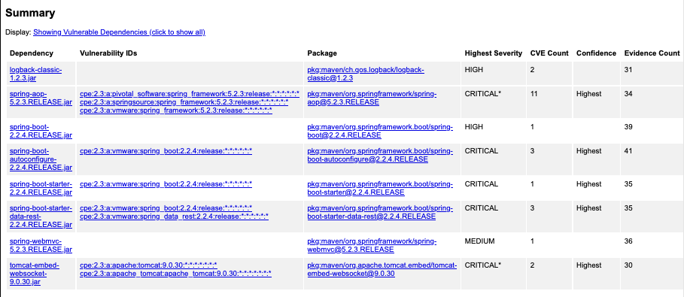

Supression.xml

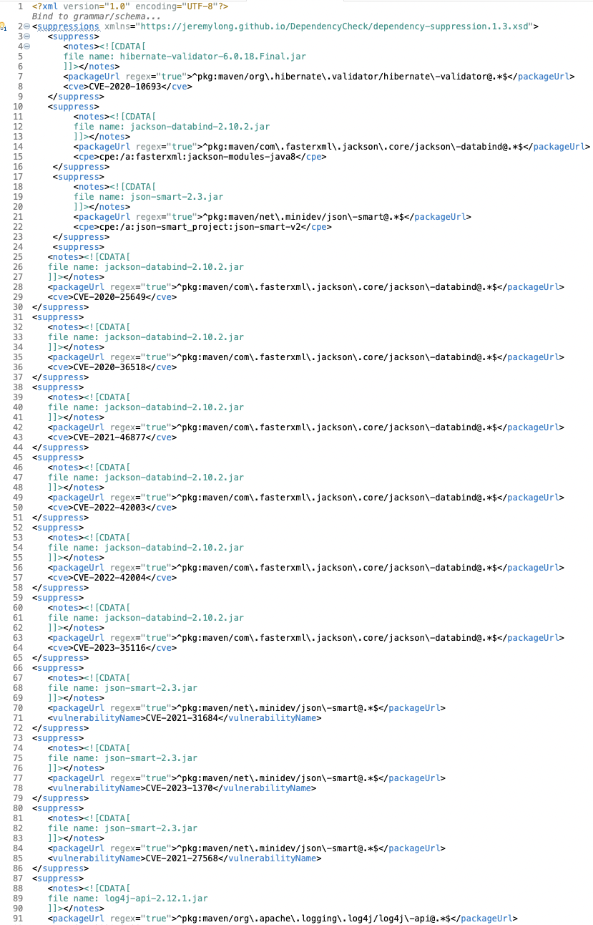

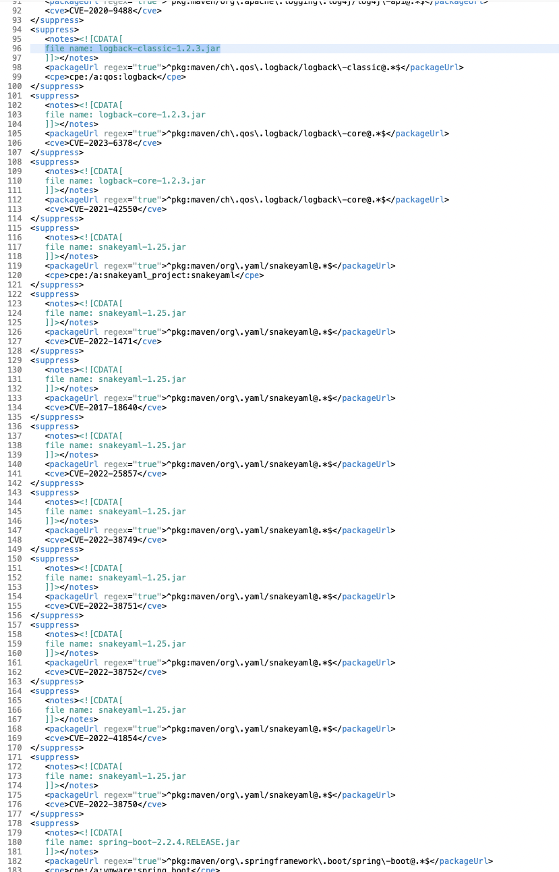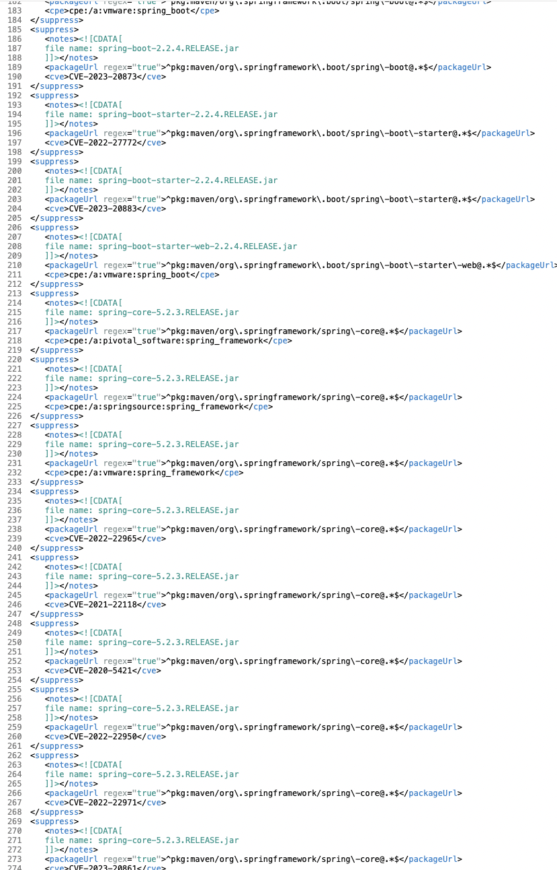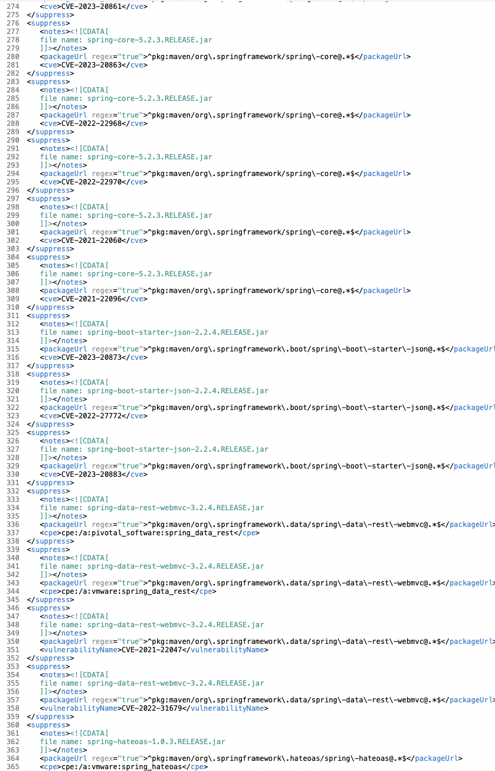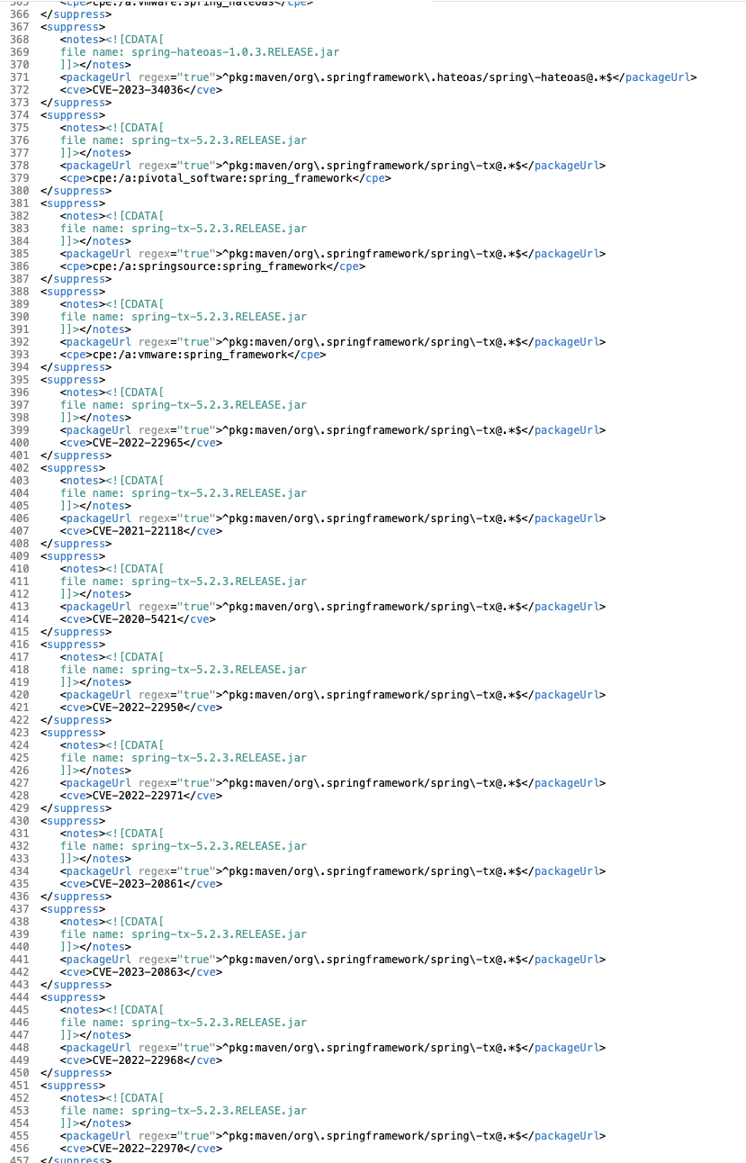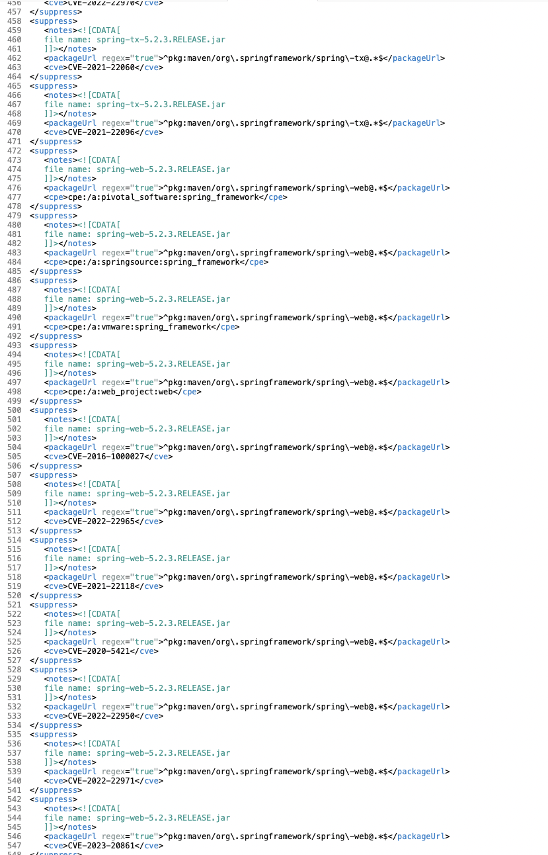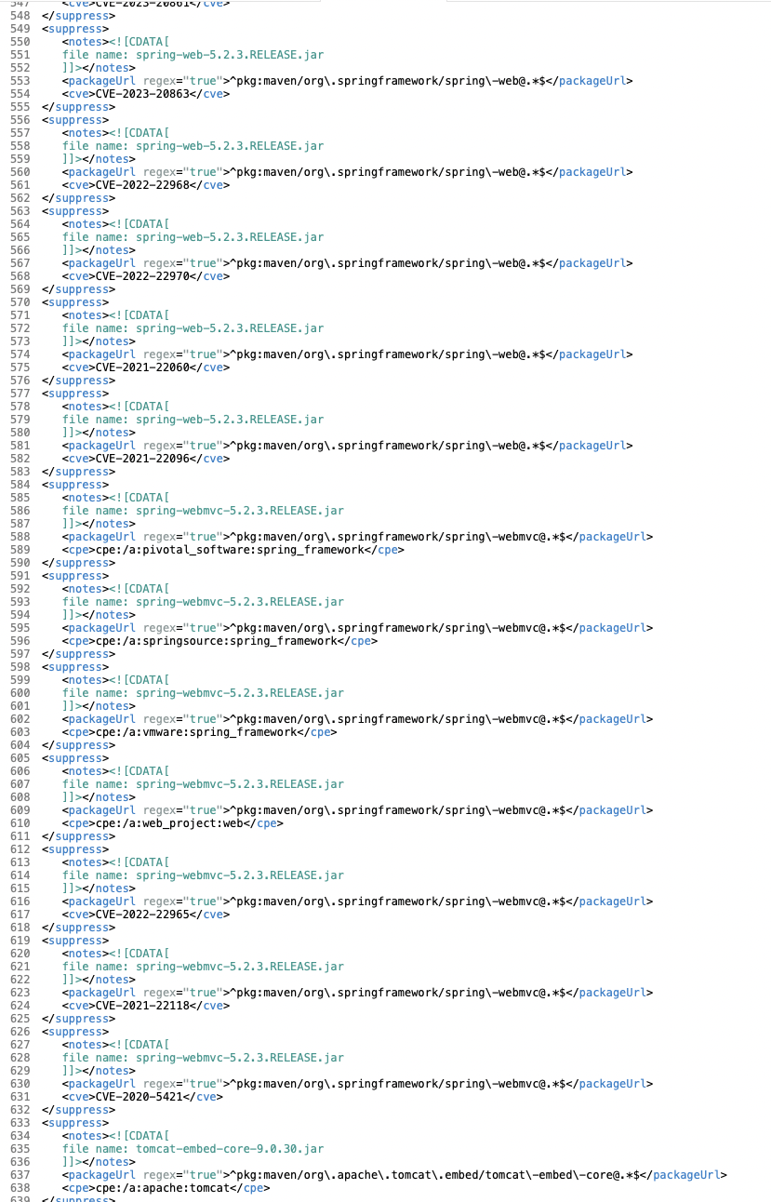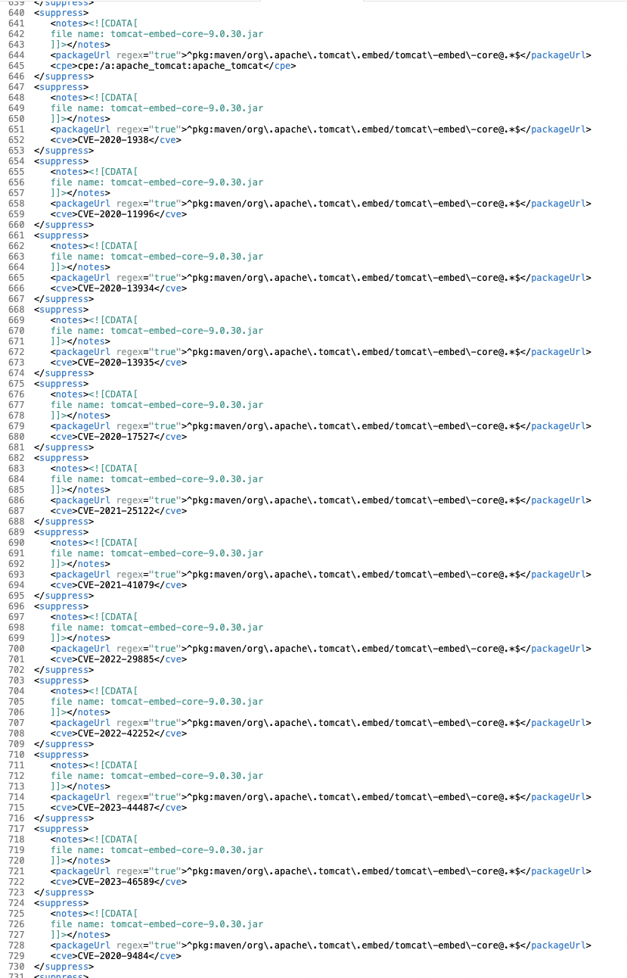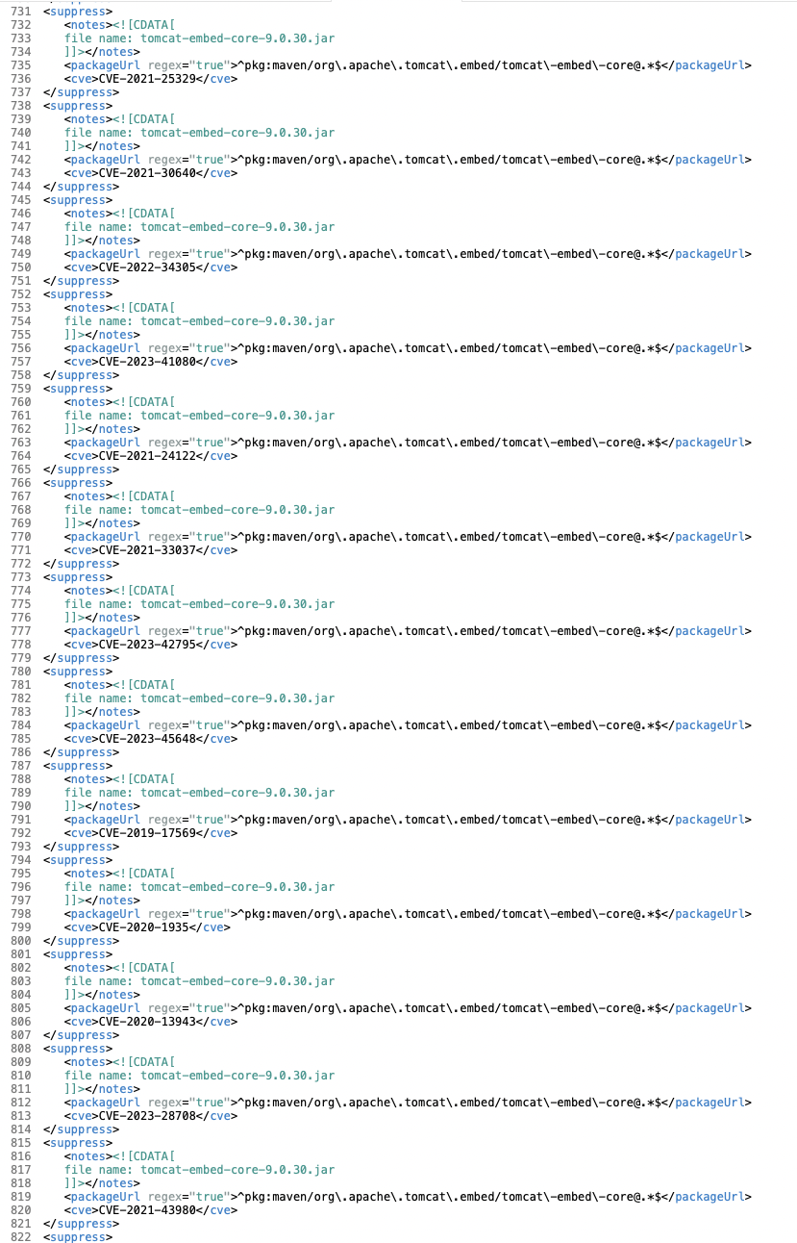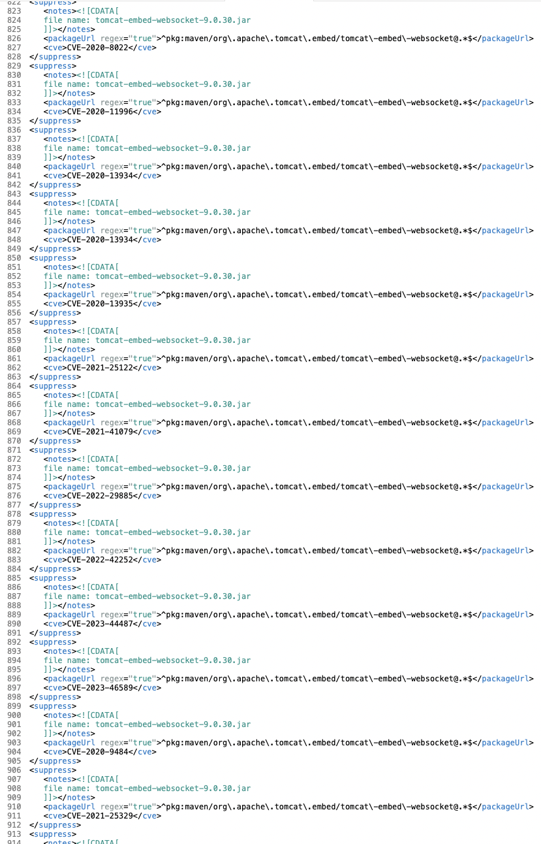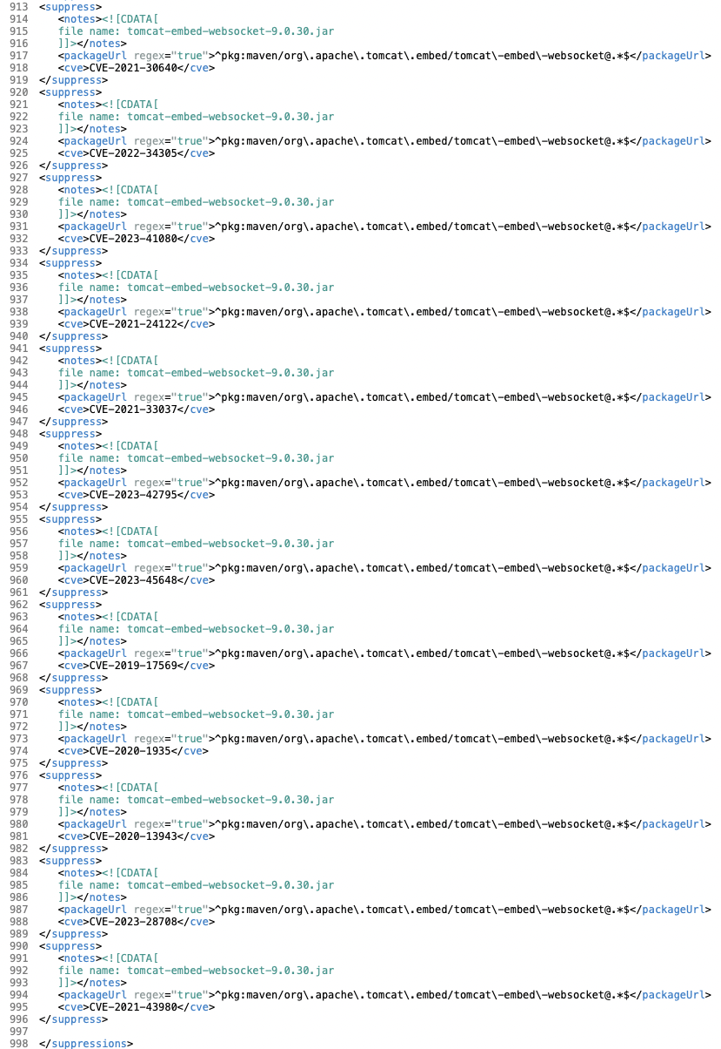

Pom.xml

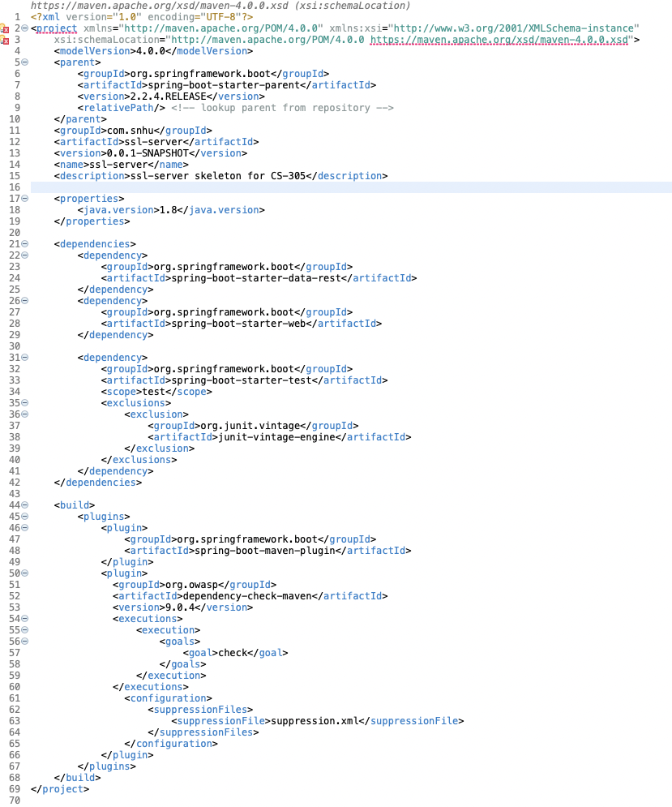

## Functional Testing

SslServerApplication.java was then refactored and a REST controller was added to the code as the hash endpoint.

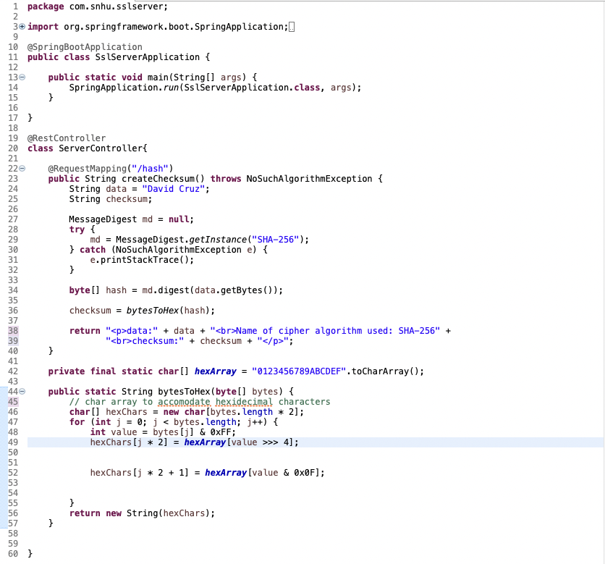

A final Dependency check was run to check for additional vulnerabilities in the code. No new vulnerabilities were seen.

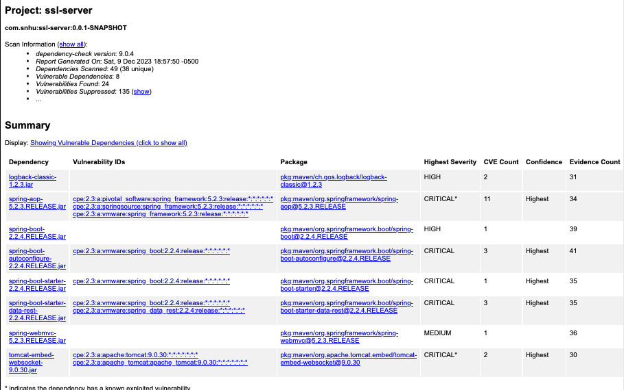

## Summary

The security concern for this application was Cryptography and the lack of a cipher algorithm that could better protect the application. The correct use of RESTful API’s was also lacking, therefore, the ServerController class was made. In this class, there is a REST controller that handles requests to the /hash endpoint and two methods. The first method, createChecksum uses a MessageDigest object which uses the cipher algorithm SHA-256. This cipher is used to compute the hash of the data string. Then it takes the hash and converts it to a hexadecimal string using the method bytesToHex. The method takes a byte array as a parameter and uses a char array containing hexadecimal digits and a for loop. Through each iteration of the for loop, each byte is converted to two hexadecimal characters which are then appended to the char array. Once the char array is completed, it is returned as a string (checksum).

To address the client/server vulnerability, the application was then tested to use HTTPS so that connections to the applications were secure. This was done by first generating a selfsigned certificate through the Eclipse Keytool extension. Then, the application.properties file was edited to specify port 8443 for incoming traffic, certificate alias and password, location of the keystore file, and keystore type. The checksum was first tested using HTTP and port 8080. Then, after the application.properties file was altered, HTTPS was tested, but the connection was still showing as not secure. This was because the certificate generated was a self-signed certificate not verified by a third-party CA. When the application goes live, this will not be a problem and the application will successfully be able to use HTTPS connections. Before the code was refactored, a dependency check was run, and vulnerabilities were suppressed in the suppression.xml file. However, some vulnerabilities continued to show even though they were inserted into the xml file, so those results were compared to the dependency check after the code was refactored. After running the dependency check post code refactor, there were no new vulnerabilities that needed to be suppressed.

## Industry Standard Best Practices

Industry best practices were used to ensure the security of the application. For instance, the REST API was used in the SslServerApplication.java file to handle requests made to the /hash endpoint using a REST Controller. REST is also a common API used in web services. Using a RESTful API improved the security, scalability, and performance of any application that implements it.

Additionally, a checksum was used to verify the integrity of the data string output by the bytesToHex function. The purpose of this is to detect if the data has been tampered when the data is in transit or stored. The checksum used the SHA-256 cipher algorithm to create a secure hash from the string. This hash prevents the data from being modified by an unauthorized user and prevents the application’s security from being compromised.

Lastly, the HTTPS protocol was used to ensure that connections to the application are secure and encrypted using Secure Sockets Layer (SSL). This ensures that the data transferred between clients and the application is authentic and confidential, and attacks like man-in-the-middle are prevented. The use of certificates verified by a CA will further bolster the security of the data transfer to and from the application. HTTPS ensures that all connections to and from the application are encrypted and secure.

Using industry best standards when coding ensures Artemis Financial’s overall wellbeing by securing their software in all aspects which in turn increases the quality of their software and satisfies their customers needs. Using a common API and best practices can make it easier for the company to comply with legal and regulatory requirements and avoid run ins with international laws and regulations. It can also reduce the possibility of receiving a security breach which can cause high costs in maintenance, dealing a blow to company revenue and even the company’s reputation. Following these bast practices can ensure that a company is successful, innovative and responsible, earning the trust and loyalty of their customers.

References

Manico, J., & Detlefsen, A. (2014). *Iron-clad java: Building secure web applications.* McGraw-

Hill Education.

Operational best practices for encryption key management - CISA. (n.d.).

https://www.cisa.gov/sites/default/files/publications/08-19-2020_Operational-Best-Practices-for-Encryption-Key-Mgmt_508c.pdf